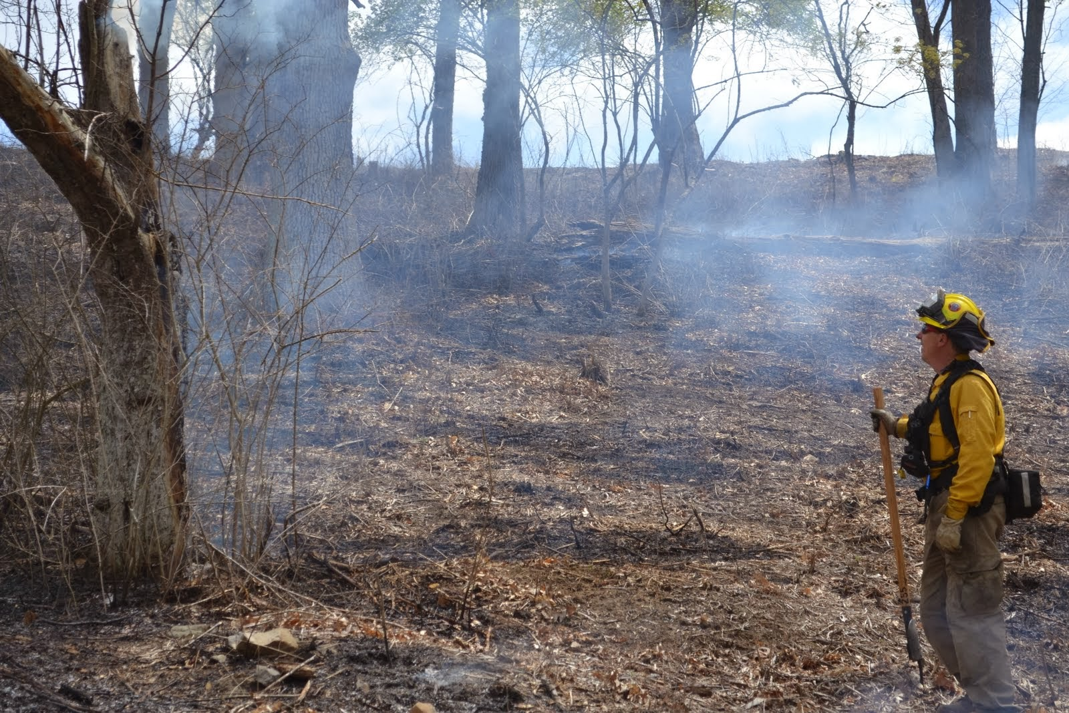
You Are Invited

Current and Future FireScapes of Pennsylvania:

linking science, management

and public perceptions

New date! Thursday, June 4, 2015
The Pennsylvania State University, Location TBD
10am – 3pm
RSVP to Erica Smithwick by Friday May 29th (smithwick@psu.edu)
Please join us for discussions about prescribed fire and wildfire preparedness in the Mid-Atlantic region. We will bring together social and ecological scientists, managers, and practitioners to explore synergies in approaches, goals, and methodology.
Lunch provided
If you need travel assistance, please contact
Erica Smithwick (smithwick@psu.edu)
Sponsored by The Center for Landscape Dynamics (www.cld.psu.edu)
& Penn State Institutes of Energy and the Environment (PSIEE) (www.psiee.psu.edu)

